Sporting Shooters’ Association of Australia (Qld) Inc. | 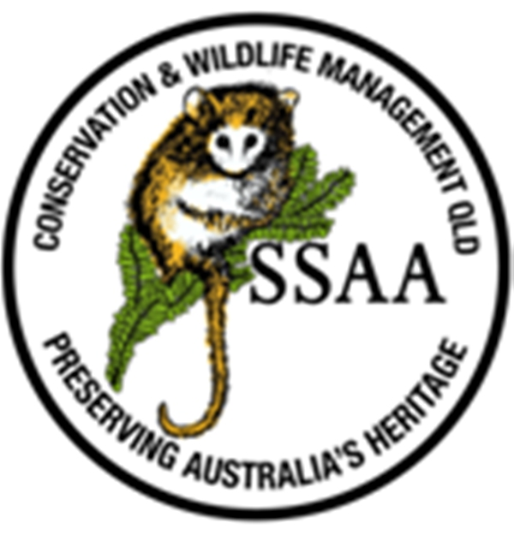
Conservation and Wildlife Management Division
“Preserving Australia’s Heritage”

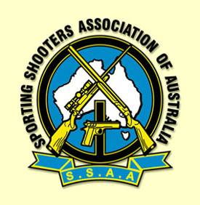 Office Postal Address: CWM, PO Box 2443, North Ipswich Qld. 4305

Email: cwm@ssaaqld.org.au

For the information of:-
- Members seeking practical Marksmanship accreditation
- Supervising SSAA Range Officers

Practical Marksmanship Qualification Requirements

There are two calibre groupings for centre fire rifles:

- Light rifle: up to and including .224 cal
- Heavy rifle: 6mm/.243cal and above.

Qualification on Benchrest and Freestanding Unsupported targets must be achieved for Accreditation. This can be done before or after you have completed the Theory Accreditation.
If you are qualified for heavy rifle, you are deemed to have also qualified for light rifle.
If you qualify for light rifle only, you must also qualify for heavy rifle before using a heavy rifle on a project.

Targets to be used are C (200m Centrefire Target).
This target may also be known as 8H (200m Centrefire Target).

Unless the center of the round falls within the inside edge of the score line, a lower score will be recorded.
There are no limits to the number of practice targets that can be used before qualification.

Target Qualification | Benchrest | Freestanding Unsupported
Distance etc | One target at 100m | One target at 100m
Number of rounds on target | 5 only | 5 only
Aids/Supports etc | Bench, Sand Bags rests, post, sitting, etc | Sling may be used. No leaning on posts etc
Minimum score | 50 | 37
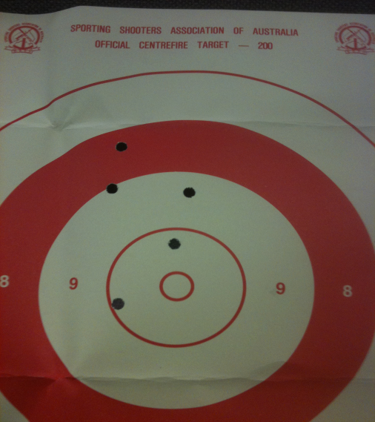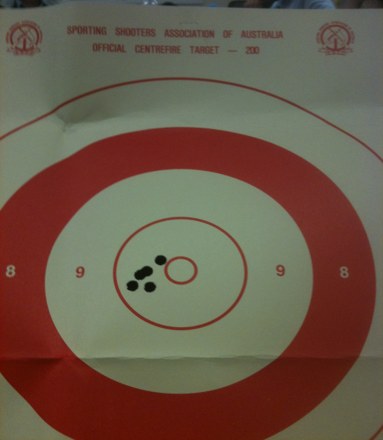

Benchrest
Example
(50pts)
Freestanding
Example (46pts)

Supervising SSAA Range Officer to witness that the CWM member has completed the practical accreditation under their supervision and include Name, range location, date, position, caliber/cartridge and score.
This accreditation is for SSAA Conservation and Wildlife Management programs and no fees are applicable, other than range use fees and consumables.
Please ensure your name and Caliber is on the target/s before sending to the office for authentication.
Clear good resolution Photos can also be e-mailed to cwm@ssaaqld.org.au .

Any questions call Mark Woods – CWM Qld State Coordinator - Phone 0438098469

